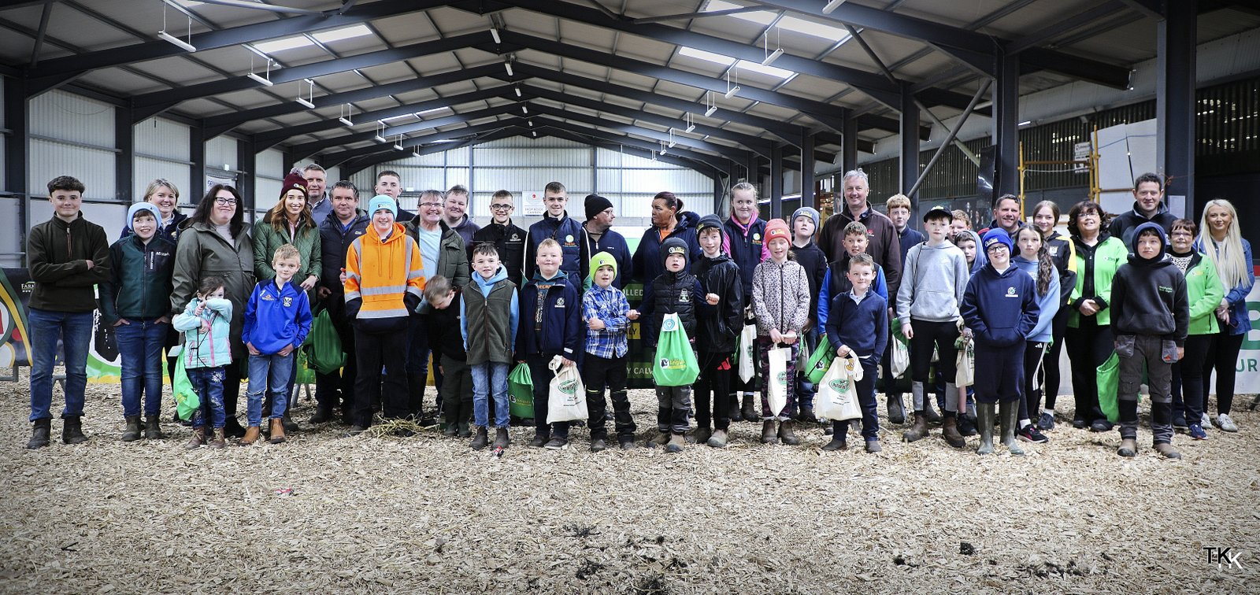
Irish Angus YDP Workshop in Carrick Highlights Learning, Safety and Youth development
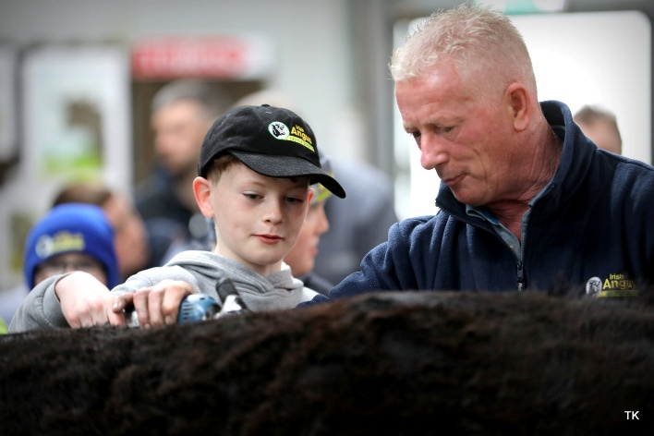
The Irish Angus Cattle Society hosted a highly successful Irish Angus YDP Workshop at the Showgrounds in Carrick-on-Shannon on Sunday, May 17th, bringing together young cattle enthusiasts, breeders, parents, and farmers for a morning packed with practical learning, demonstrations, and valuable advice. Sponsored by FBD Insurance, the event ran from 10am to 1pm and attracted a fantastic turnout from across the region.
Designed to encourage youth participation in pedigree cattle breeding and showing, the workshop catered for all ages, including adults, and created an ideal environment for both beginners and experienced exhibitors to improve their skills and knowledge. The day focused not only on preparing cattle for the show ring, but also on promoting safe livestock handling, responsible stockmanship, and confidence among young handlers.
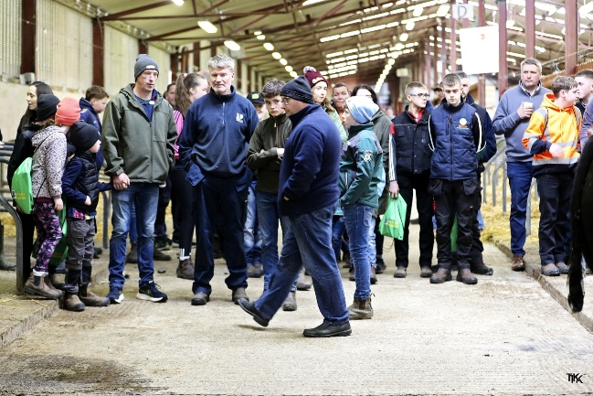
Throughout the workshop, attendees took part in a wide variety of hands-on activities including grooming, clipping and showing techniques. Demonstrations on show products and cattle preparation gave young participants an opportunity to learn directly from experienced breeders and industry figures, while also gaining practical knowledge they can use at local and national shows throughout the season.
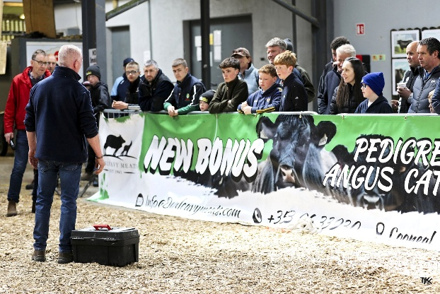
One of the strongest messages throughout the day was the importance of safety around cattle. The Irish Angus Cattle Society, Paul Fahy and speakers placed a major emphasis on proper handling techniques, animal awareness, and developing safe habits from an early age. In an industry where safety remains a key concern, the workshop provided an important platform to educate young farmers on how to work confidently and responsibly with livestock.
The event also featured informative talks and advice sessions from Natural Nutrition, members of the Irish Angus Society, and the highly entertaining and knowledgeable Paul Fahy. Their contributions added greatly to the success of the day, combining practical experience with encouragement for the next generation entering the farming industry.
A lively and welcoming atmosphere was evident throughout the event, with young handlers eager to showcase their enthusiasm for the Irish Angus breed. Spot prizes on the day added to the excitement, while light refreshments ensured attendees had an opportunity to socialise and exchange ideas with fellow breeders and participants.
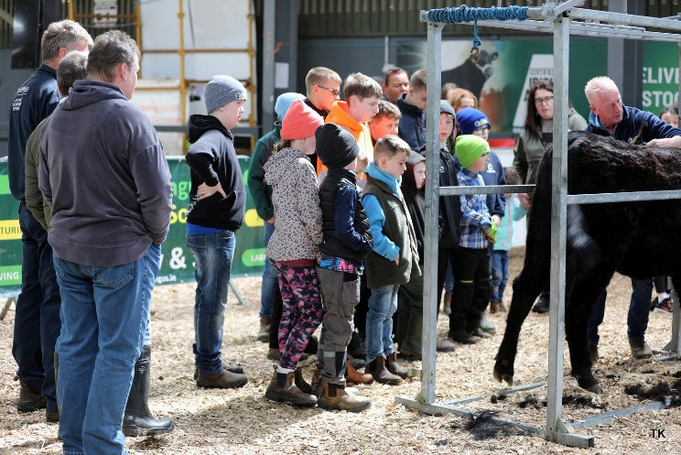
Special thanks must also go to the event sponsors and supporters including Natural Nutrition, Animal Farmacy, FarmWardrobe, Ag Mag, and FBD Insurance for their generous support and contribution towards making the workshop such a success. Their continued backing of youth initiatives within agriculture plays a hugely important role in encouraging young people to become involved in pedigree livestock and the wider farming community.
The Irish Angus YDP programme continues to play a hugely important role in developing young people’s interest in agriculture and pedigree livestock. By providing opportunities such as this workshop, the programme helps build confidence, improve practical skills, and encourage lifelong involvement within the sector.
Credit must go to everyone involved in organising the event, from volunteers and sponsors to speakers and demonstrators, whose efforts ensured a thoroughly enjoyable and educational experience for all who attended. The enthusiasm and engagement shown throughout the workshop once again demonstrated that the future of Irish Angus breeding and showing is in very capable hands.

